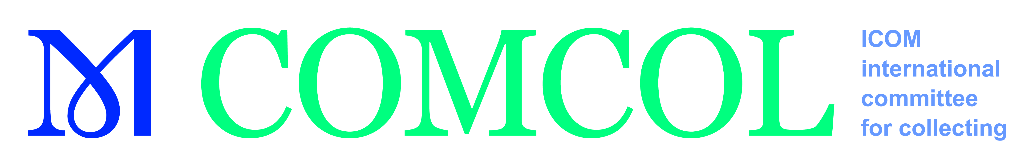

**Young ICOM Members’ Travel Grant Programme 2025**

**APPLICATION FORM**

**Support for Young Members’ participation in the general ICOM conference, 11-17 November 2025, Dubai**

To encourage young colleagues to participate in ICOM and COMCOL activities, we announce up to two travel grants of one thousand Euros (€ 1000) each for ICOM / COMCOL members who intend to take part in the general ICOM COMCONFERENCE, 11-17 November 2025 in Amsterdam.

Criteria young members travel grant:

* **35 years of age or under**,
* able to write and understand English fluently,
* museum professionals working for or with museums/heritage institutions and students with a demonstrably relevant position for collecting/collecting strategies,
* individual members of ICOM and of COMCOL,
* having submitted a proposal for a session at the conference which was accepted
* be aware that priority will be given to young members (≤ 35 years) from countries belonging to Categories 4, 3 and 2,
* be aware that young members who have received grants in the last three years (2022, 2023, 2024) will not be given priority for a grant in 2025,
* up-to-date with their membership dues for 2022, 2023 and 2024. New ICOM members who joined the organization in 2024 must have paid their dues for 2024 and 2025,
* must have a passport and be able to travel.

If you wish to apply, please **fill out** this application form and **submit** the required information to the COMCOL Secretary; Brandie MacDonald [secretary.comcol@icom.museum](mailto:secretary.comcol@icom.museum) (Subject: Young Members Application 2025)

All documents should be sent in electronically.

**Deadline of Application: The deadline for applying is 13 July 2025 at midnight. Submissions received after this date and time will not be considered.**

*Selection process: Applications will be evaluated by the COMCOL board.*

**All applications must include:**

1. the completed and signed application form

2. a 500 words motivation for attending the General Icom Conference in DUBAI answering the following questions:

* *What are the most important reasons for your motivation to participate in the conference?*
* *How will your participation in the conference benefit your museum or museum communities you work with?*
* *How do you plan to disseminate the information and knowledge gained at the conference upon your return to your home country?*

3. indication of the estimated travel costs from your home to Dubai

4. copy of a valid travel document (passport, identity card)

5. the applicant’s curriculum vitae indicating training, work experience, publications as well as current work responsibilities within his/her institution (maximum one page)

6. letter or email of approval of their proposal

7. letter of recommendation from the Chair of the applicant’s National Committee.

Each grantee will be required to submit a questionnaire **within two weeks following the meeting** stating his/her experience and contribution to ICOM and COMCOL activities, which will be used for a conference report on the COMCOL website.

**The resources for this programme are limited. Applicants are required to comply with the eligibility criteria stated in this document.**

**1. Appication Form**

|  |  |
| --- | --- |
| Applicant Details | |
| Surname(s) |  |
| First name(s) |  |
| Date of birth  *(Please include a copy of your passport)* |  |
| Individual ICOM Membership number |  |
| ICOM member since |  |
| Member of COMCOL  since |  |
| Institution |  |
| Position in your Institution |  |
| Professional Address | |
|  | |
| City Postal code Country | |
|  | |
| Telephone number |  |
| E-mail |  |

|  |  |
| --- | --- |
| Additional Information | |
| Are you an active member of other ICOM National or International Committees? (Please specify) | *Please note that you cannot attend more than one IC meeting in 2020 by means of this travel grant.* |
| Are you a member of other professional bodies/associations? |  |
| From where will you be travelling? (Please specify airport, city and country) |  |
| Do you have any additional funding possibilities? (Please specify) |  |
| Have you benefitted from ICOM Travel Grants in previous years? | *If YES, please specify the type of meeting, the venue and country, as well as the year. (for example: ICOM General Conference, Kyoto, Japan, 2019)* |
| Have you attended other COMCOL meetings or conferences? If yes, when? |  |
| Recommendation Letter | |
| Name of Recommending Person |  |
| E-Mail of recommending Person |  |
| Telephone number of recommending Person |  |

*I herewith declare:  
- that I am****35 years or younger****(as of 1 January 2020) and eligible to apply according to the*[*Criteria for ICOM Travel Programmes*](http://icommunity.icom.museum/en/node/20)*.*

- that I am available to FULLY attend the aforementioned ICOM International Committee Meeting.

|  |  |
| --- | --- |
| Date | Applicant’s Signature |
|  |  |

2. Motivation

3. indication of the estimated travel costs

*NOTE: The grants will provide assistance for airfare (in the most reasonable level of Economy Class) and assistance for accommodation for the duration of the meeting as well as registration fees. Insurance coverage, visa costs, local transportation, meals and other expenses related to the members’ participation will NOT be covered by these grants, in any circumstances.*

Further application includes in separate documents:

# Attachment: copy of a valid travel document (passport, identity card)

# Attachment: curriculum vitae

# Attachment: paper approval for the conference

# Attachment: a letter of recommendation from the Chair of the applicant’s National Committee